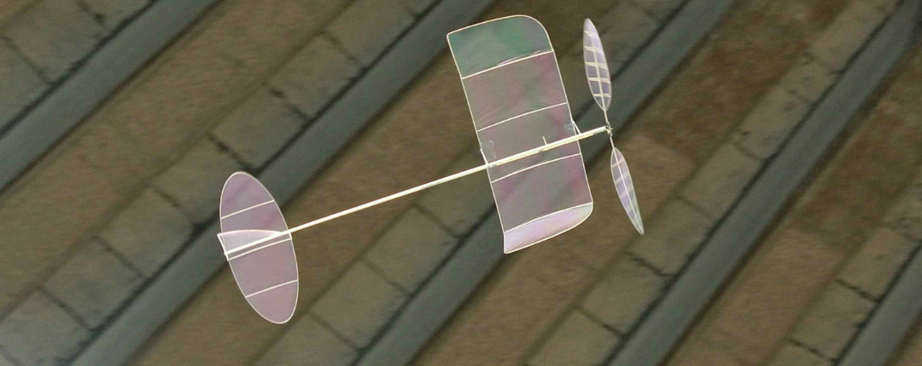
F1D World Championships Team Trial
A Team Trial will be held in Adelaide by the Adelaide Aeromodellers Club, with support from MASA, to select team members for the 2016 F1D World Championships to be held in the Slanic Salt Mines in Romania. A new ‘Boyd Felstead’ perpetual trophy will be awarded to the winner.
To find out more about competing, or to register, please contact the Contest Director preferably by email at tim.haywardbrown@gmail.com (ph 0419 825 541).
Rubber-powered free flight F1D models are the slowest recognized fixed wing aircraft in the world. An F1L (EZB) competition will be held concurrently. Come along and see a unique and unusual side of the hobby. Visitors are welcome and admission is free.
Date: Sunday 29 November 2015 (3pm to 8pm)
Venue: The Gardens Recreation Centre, Parafield, South Australia.

